Standard Revision Working Group - Phase 2 meeting 1
27th of Oct

Facilitators | Working Group | Absences
Bilge Daldeniz | Pat Brenchley | Olivia Scholtz
Bella Sosa | Ilana Weiss | Nitin Kayande
Claire Reboah | Kendyl Salcito | Peter Allsopp
 | Cristina C. López | Robert Quirk
Bonsucro | Ineke Wesseling | Mario Amador
Nahuel Tunon | Luiz Iaquinta | François-Régis GOEBEL
Nicolas Viart | Ruth Ascencio | Marina Carlini
 | Miguel Tejada Iraizoz
 | Marionne Lips
 | Danielle Lima

Objectives
Bilge presented the objectives of the meetings, which were:
- General Introductions - Facilitators & SRWG get to know each other
- Outlining the house rules & objectives, responsibilities for the Working Group
- Highlighting trends in global sustainability thinking
- Work plan and next steps.

General Introductions:
Ruth Ascencio: worked in sugar mills since 2016, mainly in quality / management systems. Currently is a consultant trainer in Bonsucro standards. For Ruth, the biggest challenge in the process has been that the first consultation was too open and lacked focus and guidance for participants.
Miguel Tejada: Miguel is a sugarcane farmer & sustainability consultant in sugar & palm oil. Miguel is also an auditor & trainer. For Miguel the biggest challenge has been managing the different points of views present in the working group and reaching suitable compromises.
Kendyl Salcito: Kendyl Is the CEO of Nomo Gaia, a non-profit research group focused on business & human rights. Their work mainly involves carrying out impact assessments. Kendyl has been working in sugar since 2014. For Kendyl, the biggest challenge has been reconciling the fact that sugar is a low value commodity with little margins, with the need to incentivise needed change in the sector.
Cristina Lopez: Social Auditor. Involved in the ISO standard revisions. Sustainability consultant. Biggest Challenge: consensus building will be the biggest challenge.
Luiz Iaquinta: H&S / environmental quality in Batira Farms. Working with Bonsucro since 2014. Works with RTRS as well. Biggest challenge: Keep focus on what we have achieved / don’t take the comments as a point to start all over again. Make the standard feasible. Prices are lower / costs are high.
Ineke (Catharina) Wesseling: Epidemiologist focusing on Occupational health – works in Chronic Kidney disease. Biggest challenge is to integrate the HR principles while maintaining a sustainable business case for certification.
Pat Brenchley: Farmer Extension at RCL foods. Vice chair of WG. Biggest challenge is implementing credible biodiversity indicators. Biodiversity is collapsing around us and we need to respond to these challenges.
Ilana Weiss: La Isla Network. Working in sugar sector since 2008 – occupational / community health. Ilana works in multidisciplinary research projects. Mainly worked in Central America but also consulted for other regions. Participant in Adelante initiative. Biggest challenge: combination of reaching an industry with a long history of practices that do not meet human rights against the business realities of the sugar industry. Also agree with ruth that the first consultation was too broad and left too much room for interpretation.
Marionne Lips: Worked on social dialogue and human rights promotion for CNV International. Biggest challenge: reach consensus for a standard that is better / stronger standard that is currently in force.
Danielle Lima: Lead auditor for Control Union. Biggest challenge will be to fit the expectations of participants and find a balance. As an auditor it will be challenging to audit this standard as it currently stands.
Bilge: Proforest over 9 years. Working in the area of MSI’s and standard revision lead facilitator for RSPO
Bella Sosa: Based in Honduras, working in responsible sourcing / supply chain initiatives.
Claire: Proforest. Supporting Bilge on the MSI. Worked in the comments on public consultation.
TOR for the working group:
Proforest will develop a document that outlines the objectives & tasks of the working group as well as an overview of the process, responsibilities and roles of the Standard Revision. This document will be developed over the next few days and will be sent to the WG. Everyone shall get a copy to guide our work ahead.
Action Points:
- Proforest to share document with Working Group by XXX

Role of Proforest in the Standard Revision
Bilge next presented an overview of the work and purpose of Proforest, highlighting their experience working in multi-stakeholder initiatives as well as their expertise in facilitating complex revisions. Bilge also shared what will be their role in the process, namely:
- Technical Facilitation of entire process including running SRWG calls, subgroup calls, public consultation
- Writing of standard (based on the SRWG decisions)
- Writing of the guidance ( based on the SRWG decisions

Framing phase 2 of Standard Revision:
Bella presented the latest trends in sustainability standard highlighting the current international legislation that is in force as well as all of the other legislation that is in the process of being adopted in the near future. Bella highlighted that the trends has been for international legislation has moved from Reporting of actions (disclosure) to Mandated Action and Reporting (HRDD).
In the latest environmental trends, Bella mentioned that the latest due diligence requirements in certain commodities are moving towards focusing on deforestation or no conversion of natural ecosystems. On Green House Gasses / Carbon stocks, the trend is to focus on GHG reduction commitments on downstream operators.

Main comments from public consultation:
Bilge highlighted some of the main themes that came out during the first public consultation and what are the actions that the WG will need to take to address them.
- Scope of Certification: WG will need to clarify several aspects as some of the pushback seems to be have caused by confusion around expectations.
- National Interpretation : this will be passed to the TAB as this is outside the scope of certification:
- Lack of Guidance: This is something that will be addressed in the second phase.
- Progressive implementation: dedicated sub working group to set out expectations will be set up to look at this

New Subgroups & remote work:

Bilge shared with the working group the updated methodology and timelines for the remainder of the Standard Revision Process. The updates are due to challenges presented by Covid-19 & the inability for the working group to meet in person. Challenges include a large revision group (17 members) spread across different geographical zones.
Highlight of specific changes:
- Working group will be divided amongst 3 sub working groups
  - Social (P2)
  - Environmental (P3 / 4)
  - Progressive Implementation & Continuous Improvement (P1 / P5)
- Easier issues will aim to address via remote methodology:
- Only most contentious topics will be debated in the sub working group calls
- Cross Cutting / strategic topics: will aim to advance in subgroups, but likely defer to full SRWG if a solution is not straight forward
- Aim to have one WG member join a single sub-group
  - ALL working group comments will have opportunity to give input / comment on all aspects of the standard.
  - Several iterations of the draft will be shared with all the working group.
Members of the SRWG shared their concerns around the methodology proposed as well. Namely that each working group to only join one group. In the previous phases, the working group worked across different sub working groups and they would like to continue to work according to those terms.
UPDATE: After discussions between the working group & facilitators, the sub-working group have been expanded to one per principle. P3 working group will meet only remotely as there are no contentious issues to discuss there.

Timeline:

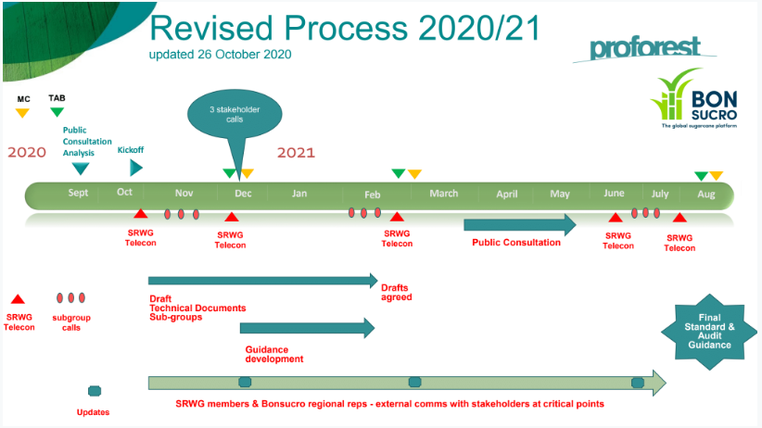
Bilge shared the revised timeline for the remainder of the process. Particularly noteworthy are that 3 stakeholder calls will be set up in December with CNV, Australian Producers & Central American Producers. The timeline also incorporates different check-in points at critical times with the Bonsucro Governance bodies and with the wider stakeholdership.

Actions:
- Nahuel to share again the feedback template and the recording of the summary of comments webinar.
- SRWG: to fill out the template by the 29th of October.
- Dropbox will be created by Proforest to share documents and collaborate.
- Notes of this meeting will be shared to the group

Addendum:
Calls set up with those who could not attend the first meeting to share important information regarding the methodology and the next steps.
Present: Robert, Olivia, Mario
Absent: Nitin, Peter, Regis, Marina

